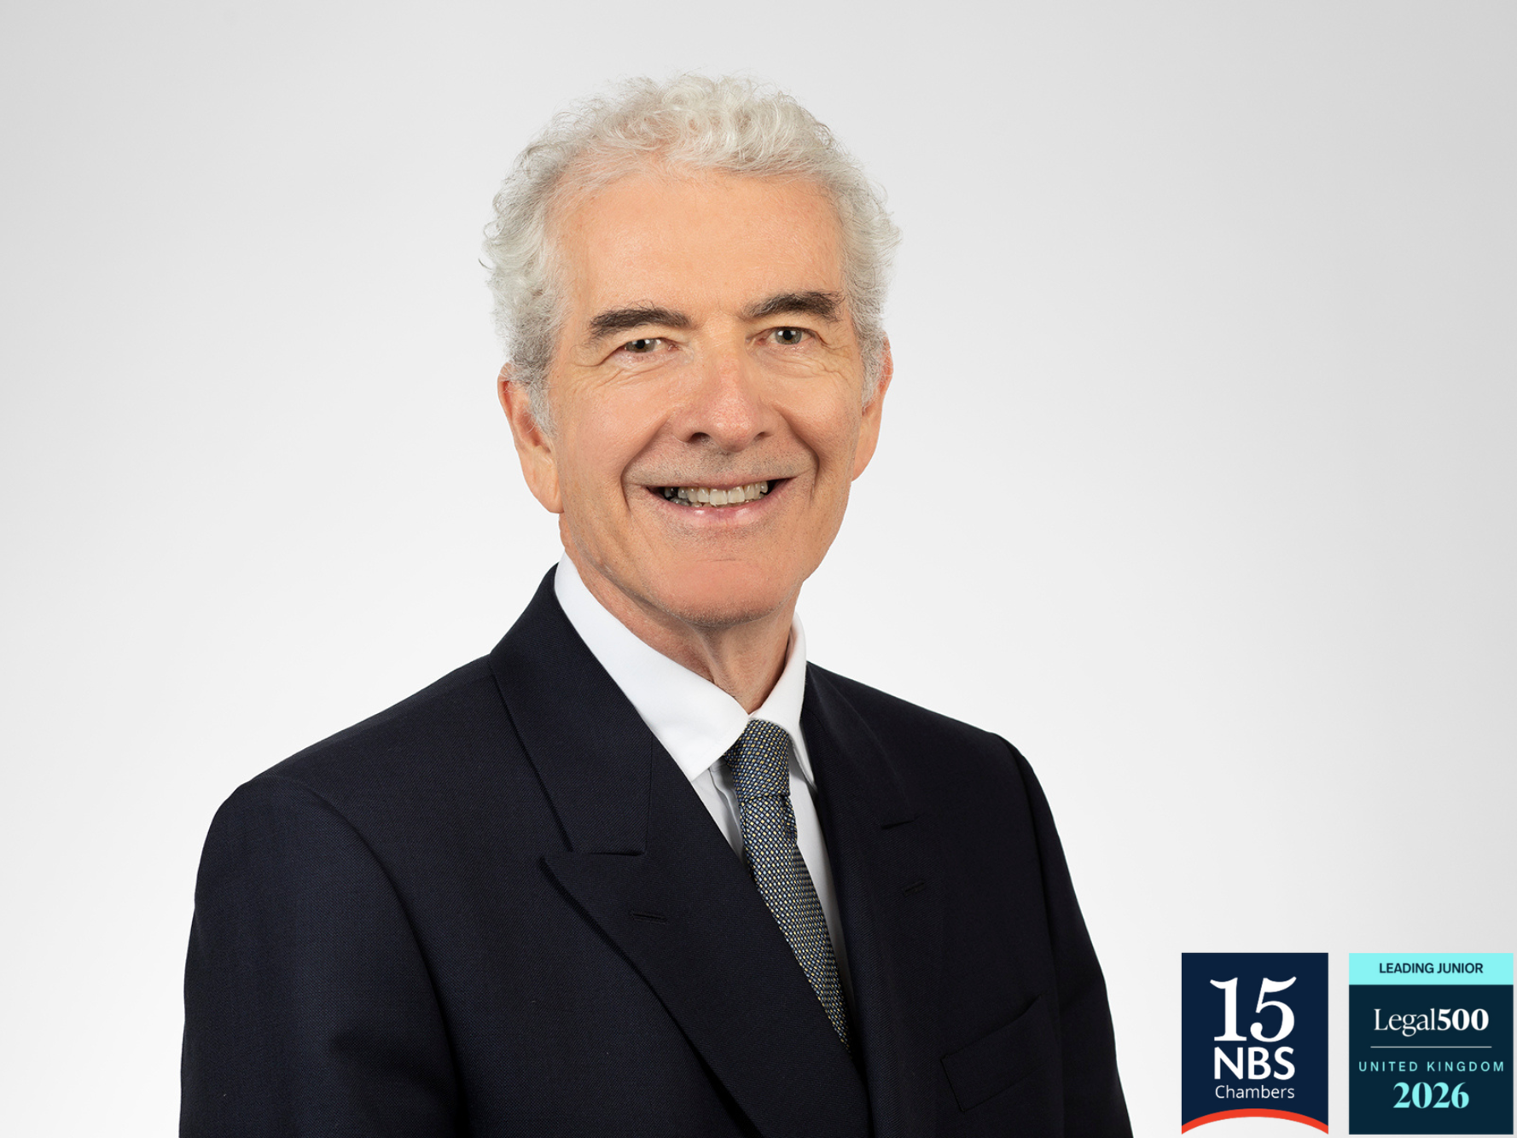

RORY FIELD

YEAR OF CALL: 1980

‘A junior of exceptional ability and huge experience. A Silk only missing the letters.' (Legal 500 – 2026)

‘Rory is an extremely intelligent barrister who puts his heart and soul into cases. His advocacy skills are unbeatable and he is a tenacious cross-examiner. Rory is very logical and pays great attention to detail.’ (Legal 500 - 2025)

“Rory is plainly a skilled and experienced advocate. He doesn’t miss a question in cross-examination and gives compelling closing speeches. He is a pleasure to work with and polite and friendly at all times.” (Legal 500 – 2024)

Rory has unique skills and experience as a leading advocate and in trial strategy and management in the most serious and complex matters. Rory spent 10 years overseas as Director of Public Prosecutions of 2 jurisdictions, most recently Bermuda. He now only defends but brings his wealth of senior advocacy skills and strategic thinking to his cases. He has a reputation for meticulous preparation and fearless advocacy. He is particularly praised for his cross-examination and his persuasive closing speeches.

His practice is focused on fraud and business crime, general crime, international crime including extradition, regulatory proceedings and matters related to whistleblowers. Rory is a former OSCE Advisor on Organised Crime and a former Senior Advisor, Criminal Cartels at the Competition and Markets Authority.

His business crime experience includes allegations of corruption and misconduct in public office, high value fraud, large scale international money laundering and related misconduct, including political corruption. Rory is Chair of the 15NBS Fraud and Regulatory Committee.

His general criminal experience includes homicide (murder, including multi victim gang murder, as well as attempted murder and manslaughter), high value drugs offences, including large scale importation, firearms offences, kidnap and serious sexual offending.

He provides advice and advocacy in complex, substantial and sensitive cases, including those with an international element. Advice is often sought at an early stage in proceedings. Rory is instructed privately, under legal aid and by direct access. He is an International Commercial Arbitrator (FCIArb) and an Accredited Civil and Commercial Mediator. In 2023 and 2024 Rory advised a Qatar based commercial enterprise on recovery of assets held in the UK, further to criminal proceedings in Qatar.

Rory has contributed a chapter to Perspectives on Elderly Crime and Victimization edited by Peter C. Kratcoski and Maximilian Edelbacher. Rory has contributed numerous articles to legal magazines, including Counsel magazine. Rory has conducted presentations on criminal law issues all over the world and regularly speaks at the Cambridge International Economic Crime Symposium, Judges at the annual Vienna based Vismoot arbitration Moot and is an Assessor at the annual Vienna based IBA-VIAC Mediation Competition.

NOTABLE CASES

R v F R
Conspiracy to commit fraud by false representation. Two three-month trials. A third follows in 2026.

A v Spain
Issues around undercover police work and allegations of police corruption

IPOC case
Allegations of providing false information and perverting the course of justice in relation to a £1.9 billion asset result in £34 million confiscation

R v G S
Conspiracy to rob. Trial collapses after disclosure applications indicate fraudulent collusion between some defendants and ‘victims’.

R v J P
prohibition on the export of goods. Encouraging or assisting. Trademarks Act Offence. Large scale conspiracy involving the production of over £4 million of fake drugs and sale of drugs into countries including the USA.

R v T B
Four counts of rape of a child under 13.

R v A D
Operation Solidago (2023) – Conspiracy to supply large quantity of class A drugs into South Wales by OCG group.

R v I M
Multiple serious sexual assaults and perverting the course of justice.

R v F M
Conspiracy to supply class A drugs. Running a drugs line. Undercover police operation.

R v J T
Conspiracy to steal in excess of £1 million of high-end cars and break them up, using sophisticated technology.

R v M B
Multi handed kidnap, false imprisonment, grievous bodily harm with intent and robbery. Client had very significant mental health issues requiring fitness to plead arguments and a full-time intermediary. Two trials.

R v F D
Firearms and drugs case. Issues around access to the firearms and explanations for strong forensic evidence.

R v N A
Operation Vent. Conspiracy to supply class A drugs into the Midlands by London based OCG.

R v N R
Operation Blessed. Conspiracy to supply class A drugs.

R v E D
Operation Canterbury (2021) – sensitive case involving allegations of corruption involving an employee of the Office of the Director of Public Prosecutions of the Cayman Islands relating to the unlawful concealing and deletion of prosecution files.

R v J Z
Member of Latvian organised crime group importing £37 million class A drugs plus firearms.

Myers et al v R
Murder trial which then led to a Privy Council case considering issue of whether a police officer can be an expert witness.

Johannes Deuss v AG
Privy Council case involving extradition of JD to the Netherlands and whether the extradition was lawful.

PROFESSIONAL ASSOCIATIONS

Fraud Lawyers Association
Criminal Bar Association
South-Eastern Circuit
International Bar Association
Bar Human Rights Committee
Fellow of Chartered Institute of Arbitrators (FCIArb)
Middle Temple

QUALIFICATIONS AND AWARDS

Cambridge University Law Hons MA and BA
Kitchener Scholar
Accredited Civil and Commercial Mediator

CURRENT ASSOCIATED WORK

Senator of the International Association of Prosecutors
Vice Chair of Legal panel of Whistleblowers UK

